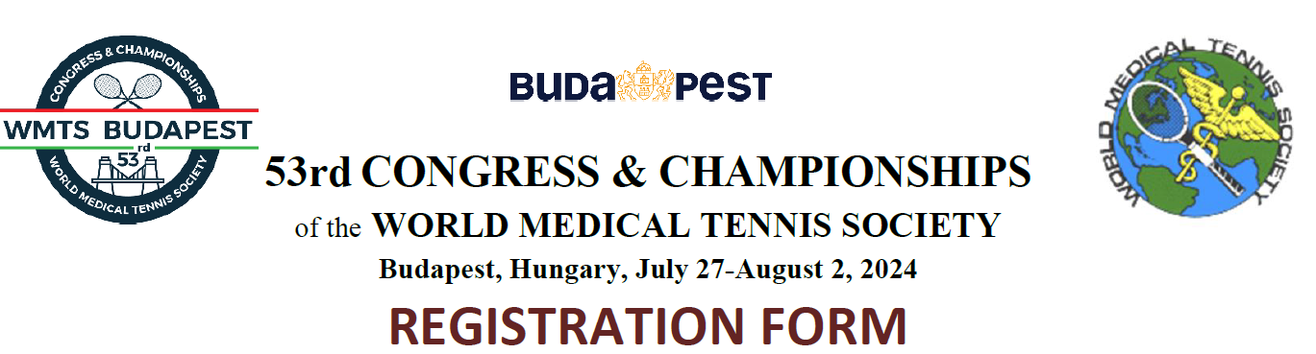
SURNAME: |  | NAME:

SPOUSE’S SURNAME: |  | SPOUSE’S NAME:

CHILDREN’S NAMES AND Y.O.B.:

COUNTRY (PASSPORT)

MEDICAL SPECIALIZATION: |  | SPOUSE’S IF MD:

PHONE:

E-MAIL:
- Registration and participation in the tennis tournament is restricted to physicians and spouses or life partners.
- Children may play a separate tournament depending on number of participants.
- Each official WMTS delegate is responsible for the qualifications of registrants from their countries.
Category | Before  March 31, 2024 | After  March 31, 2024 | Number  of persons | Amount in Euro
Physician | EUR 490 | EUR 550
Spouse player | EUR 390 | EUR 450
Non playing guest | EUR 290 | EUR 350
Junior 12-18 years | EUR 100 | EUR 150
Child < 12 years | free | free
 |  |  | TOTAL EUR
REGISTRATION FEE INCLUDES: tennis tournament, scientific sessions, welcome reception, national evening, awards ceremony, farewell dinner, bus transportation, WMTS contribution fee.
