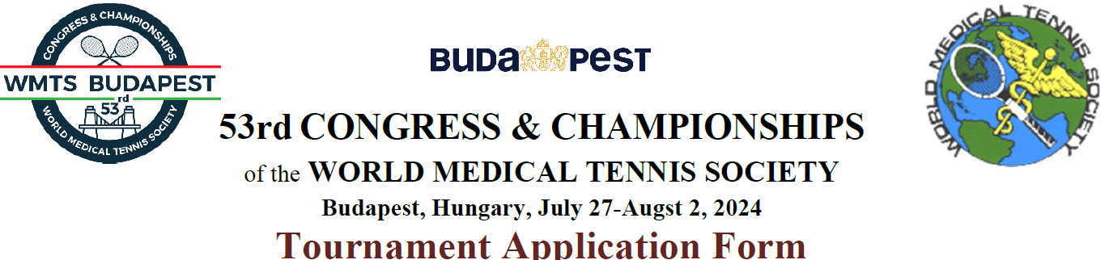

SURNAME: |  | FIRST NAME: |  | YEAR OF BIRTH:

SPOUSE’S SURNAME: |  | FIRST NAME: |  | YEAR OF BIRTH:

Please read the following instructions carefully! Each player may enter a maximum of three (3) Events.
- Each player may enter one Singles, one Ladies’ or Men’s Doubles and one Mixed Doubles. Those registered for mixed doubles who cannot get a partner may play another age doubles category (depending on number of participants).
- Only male or female physicians/dentists may enter singles event designated as “MD”.
- Non MD players (wives/husbands and life partners) may enter NON MD Singles; Ladies’ and Men’s Doubles; Mixed Doubles.
- Non MD daughters/sons of physicians/dentists can only play a separate children’s tournament, not Doubles or Mixed Doubles.
- Players are guaranteed two matches per each event.
- Winners report score. First match losers (in the 1st or 2nd round) report intent to play consolation tournament immediately after the match.
- Courts surface: outdoor clay, indoor hard - in case of rain. Please bring 2 pairs of tennis shoes!

PLEASE MARK THE EVENT YOU AND YOUR SPOUSE WISH TO ENTER
LADIES’ MD SINGLES | MEN’S MD SINGLES
1 Ladies’ MD Open Singles | 11 Men’s MD Open Singles
2 Ladies’ MD 40+ Singles (Born 1984 or earlier) | 12 Men’s MD 40+ Singles (Born 1984 or earlier)
3 Ladies’ MD 45+ Singles (Born 1979 or earlier) | 13 Men’s MD 45+ Singles (Born 1979 or earlier)
4 Ladies’ MD 50+ Singles (Born 1974 or earlier) | 14 Men’s MD 50+ Singles (Born 1974 or earlier)
5 Ladies’ MD 55+ Singles (Born 1969 or earlier) | 15 Men’s MD 55+ Singles (Born 1969 or earlier)
6 Ladies’ MD 60+ Singles (Born 1964 or earlier) | 16 Men’s MD 60+ Singles (Born 1964 or earlier)
7 Ladies’ MD 65+ Singles (Born 1959 or earlier) | 17 Men’s MD 65+ Singles (Born 1959 or earlier)
8 Ladies’ MD 70+ Singles (Born 1954 or earlier) | 18 Men’s MD 70+ Singles (Born 1954 or earlier)
9 Ladies’ MD 75+ Singles (Born 1949 or earlier) | 19 Men’s MD 75+ Singles (Born 1949 or earlier)
10 Ladies’ MD 80+ Singles (Born 1944 or earlier) | 20 Men’s MD 80+ Singles (Born 1944 or earlier)
LADIES’ DOUBLES | MEN’S DOUBLES
21 Ladies’ Open Doubles | 31 Men’s Open Doubles
22 Ladies’ 40+ Doubles (Born 1984 or earlier) | 32 Men’s 40+ Doubles (Born 1984 or earlier)
23 Ladies’ 45+ Doubles (Born 1979 or earlier) | 33 Men’s 45+ Doubles (Born 1979 or earlier)
24 Ladies’ 50+ Doubles (Born 1974 or earlier) | 34 Men’s 50+ Doubles (Born 1974 or earlier)
25 Ladies’ 55+ Doubles (Born 1969 or earlier) | 35 Men’s 55+ Doubles (Born 1969 or earlier)
26 Ladies’ 60+ Doubles (Born 1964 or earlier) | 36 Men’s 60+ Doubles (Born 1964 or earlier)
27 Ladies’ 65+ Doubles (Born 1959 or earlier) | 37 Men’s 65+ Doubles (Born 1959 or earlier)
28 Ladies’ 70+ Doubles (Born 1954 or earlier) | 38 Men’s 70+ Doubles (Born 1954 or earlier)
29 Ladies’ 75+ Doubles (Born 1949 or earlier) | 39 Men’s 75+ Doubles (Born 1949 or earlier)
30 Ladies’ 80+ Doubles (Born 1944 or earlier) | 40 Men’s 80+ Doubles (Born 1944 or earlier)
MIXED DOUBLES | LADIES’ SINGLES (NON MD)
41 Mixed Open Doubles | 51 Ladies’ Open Singles
42 Mixed 40+ Doubles (Born 1984 or earlier) | 52 Ladies’ 40+ Singles (Born 1984 or earlier)
43 Mixed 45+ Doubles (Born 1979 or earlier) | 53 Ladies’ 50+ Singles (Born 1974 or earlier)
44 Mixed 50+ Doubles (Born 1974 or earlier) | 54 Ladies’ 60+ Singles (Born 1964 or earlier)
45 Mixed 55+ Doubles (Born 1969 or earlier) | 55 Ladies’ 70+ Singles (Born 1954 or earlier)
46 Mixed 60+ Doubles (Born 1964 or earlier) | MEN’S SINGLES (NON MD)
47 Mixed 65+ Doubles (Born 1959 or earlier) | 56 Men’s Open Singles
48 Mixed 70+ Doubles (Born 1954 or earlier)
49 Mixed 75+ Doubles (Born 1949 or earlier)
50 Mixed 80+ Doubles (Born 1944 or earlier)

Ladies’ Doubles Partner: |  | Men’s Doubles Partner:

Ladies’ Mixed Doubles Partner: |  | Men’s Mixed Doubles Partner:

If you want to play, but do not have doubles partner, please indicate “need a partner”.

